**Unit 12: Some Applications of Functions**

**12-1 Displacement vs. Distance**

Absolute value

When is he furthest east, furthest west? What does he do at those times (turns around). Some with several turning around, including endpoint = max.

How many different points are a certain distance away from given point?

What distance is needed to accomplish a certain displacement? (or vice versa?): Johnny is walking along an east-west road (east = positive, west = negative). Describe a journey (or as many journeys as you can) that Johnny could achieve a (Note: Could give a specific starting position or not. Should not be 0):

1. Distance of 5 miles
2. Distance of -3 miles
3. Displacement of 6 miles.
4. Displacement of -4 miles
5. Distance of 5 miles and displacement of 5 miles
6. Distance of 5 miles and displacement of -5 miles
7. Distance of 7 miles and displacement of 5 miles
8. Distance of 5 miles and displacement of 7 miles
9. Distance of 5 miles and displacement of -7 miles
10. Distance of 5 miles and displacement of -3 miles
11. Etc.

S-Z Chap. 2 p. 183

Interpret some of these wrt dist/displ?

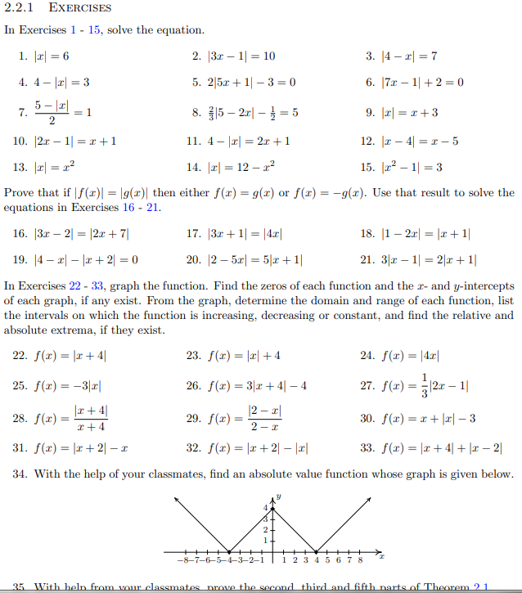

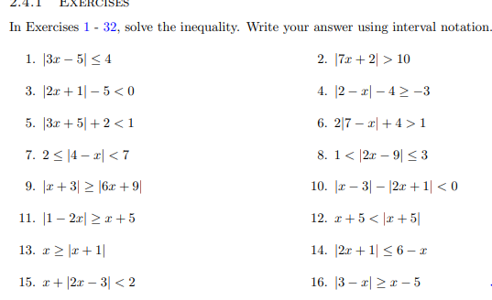

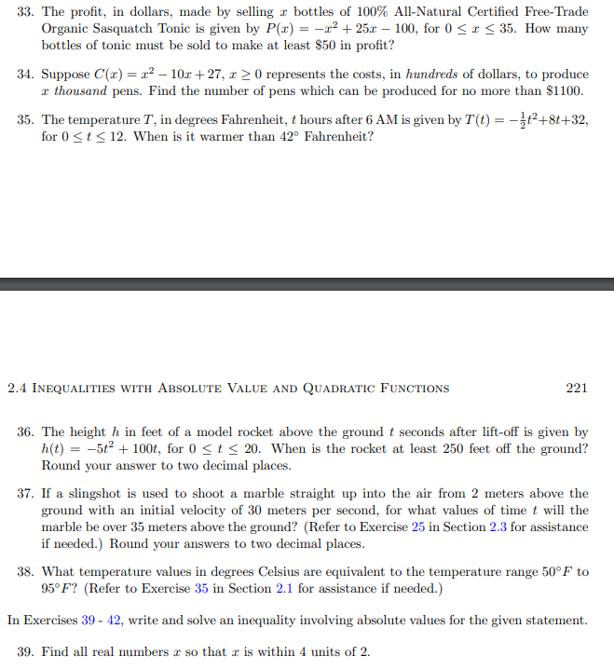

MFG: 2.5:

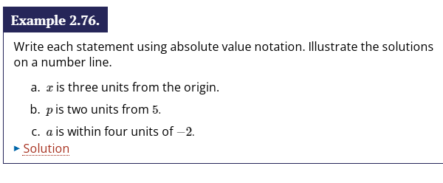

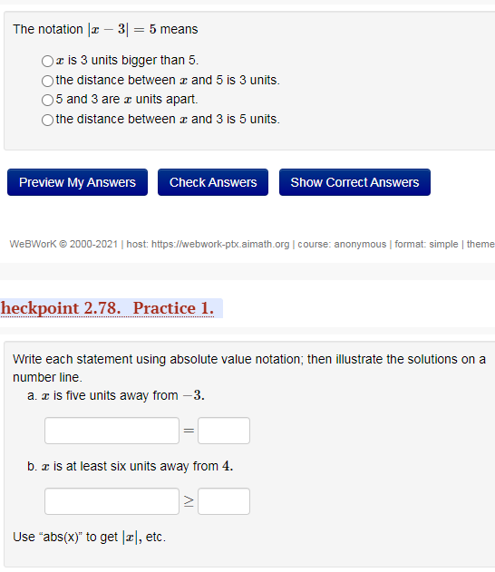

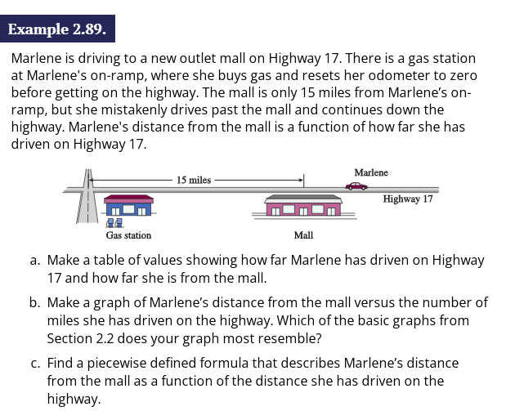

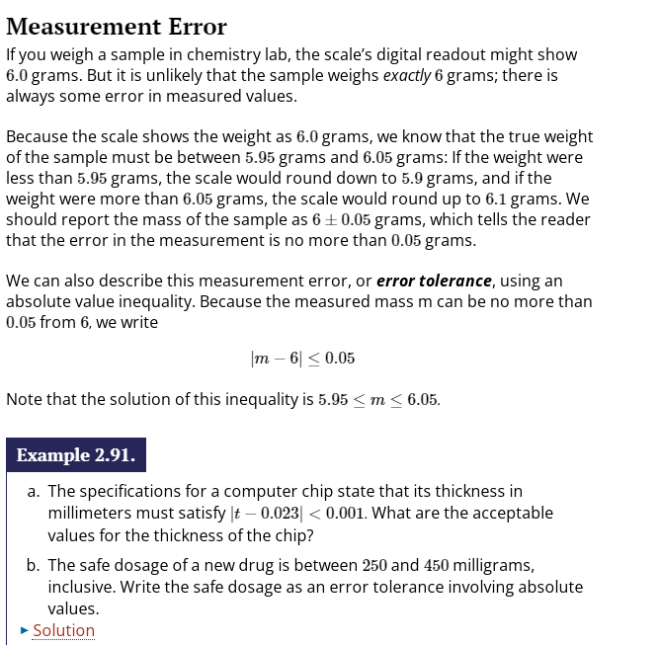

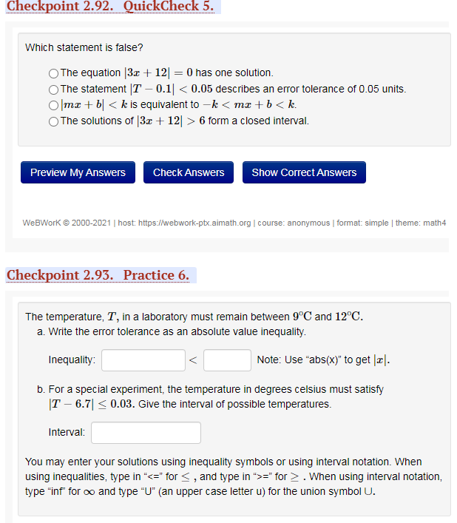

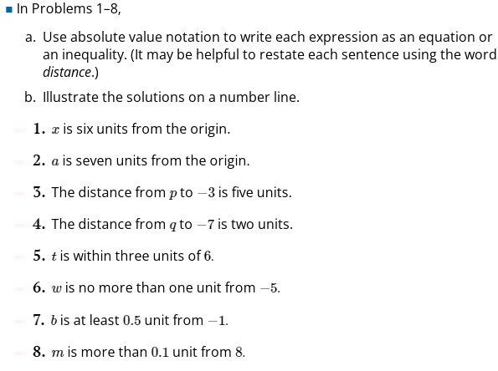

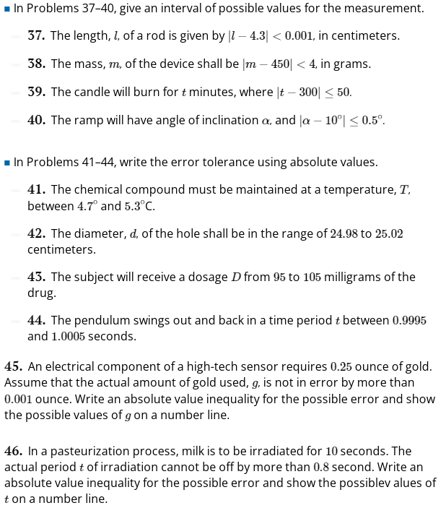

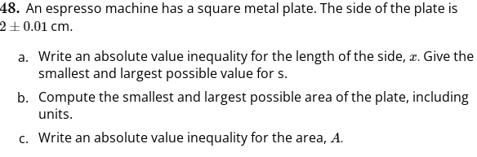

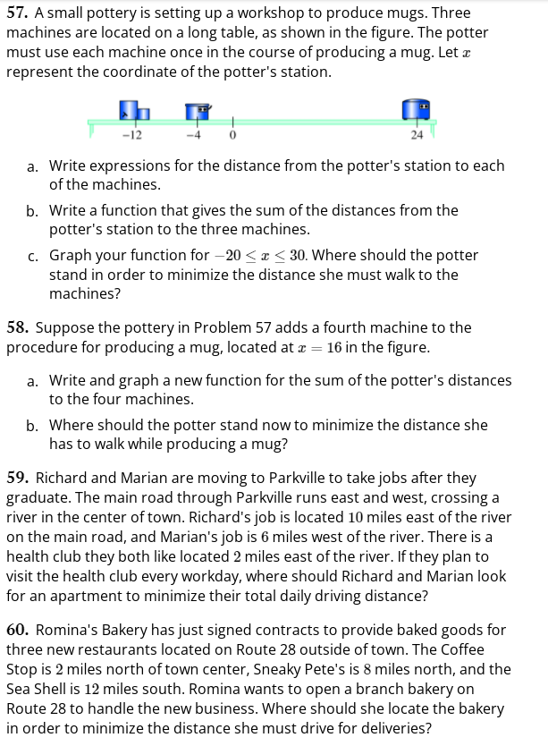

MFG: Chap. 2 Review

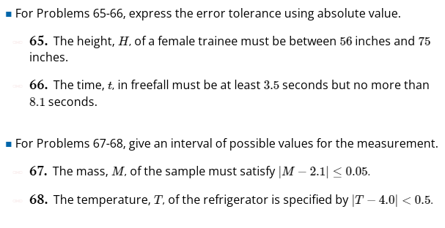

**12-2: Solving Inequalities**

Find domain of square root, log functions

**S-Z p. 232 2.4:**

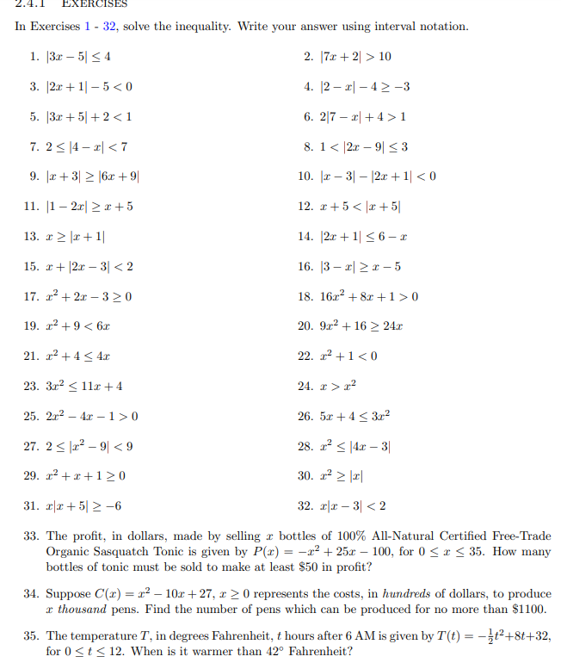

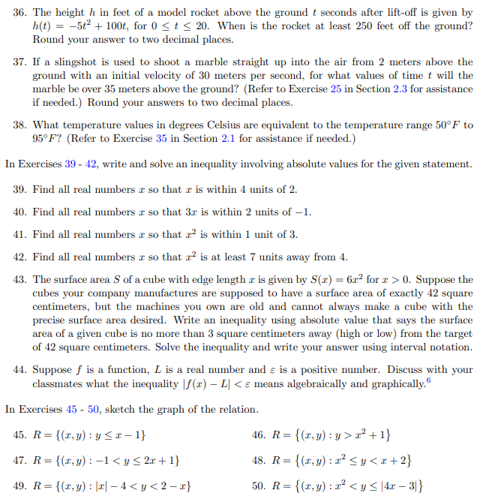

**S-Z** **3.3 p. 293**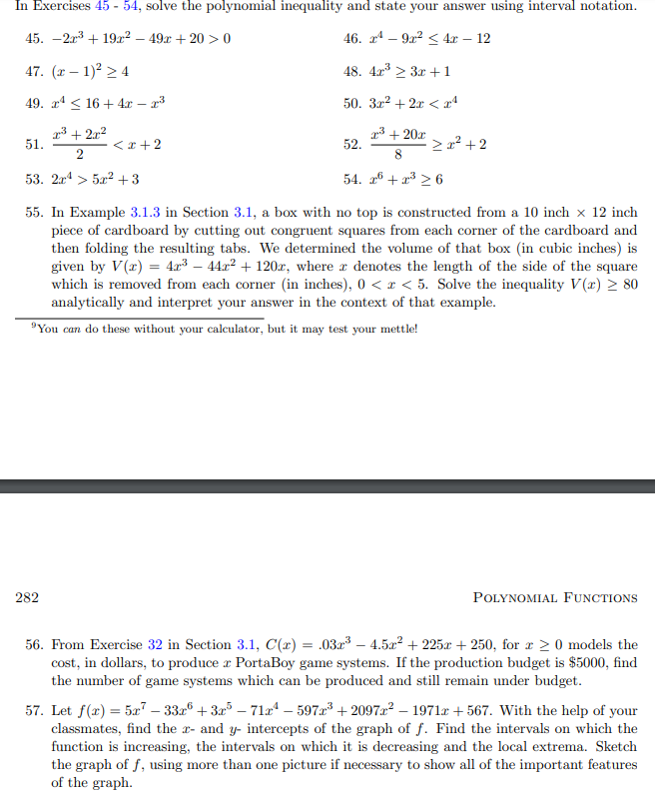

**S-Z p. 353 4.3:**

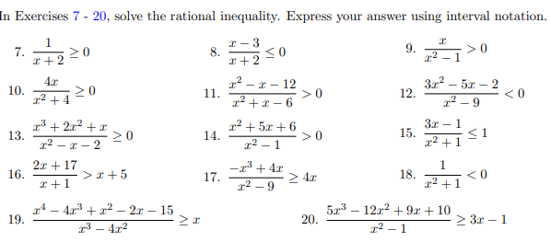

**S-Z p. 451 6.3:**

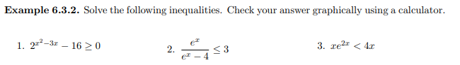

S-Z p. 458 6.3:

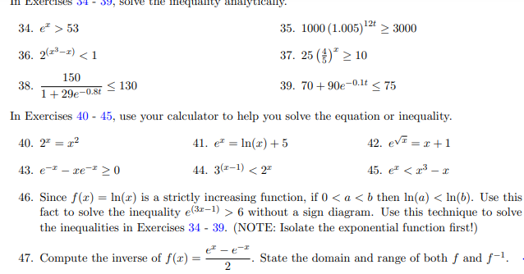

S-Z p. 462. 6.4:

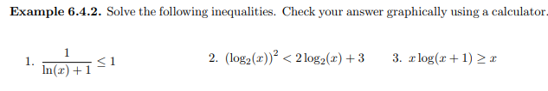

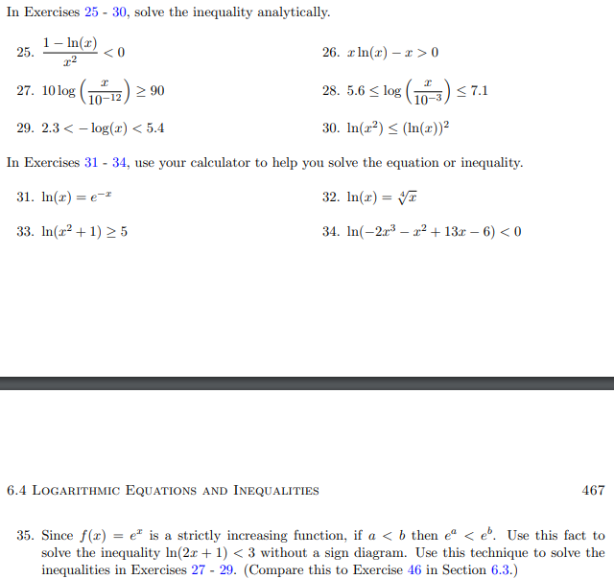

S-Z 10.7 p. 875-6:

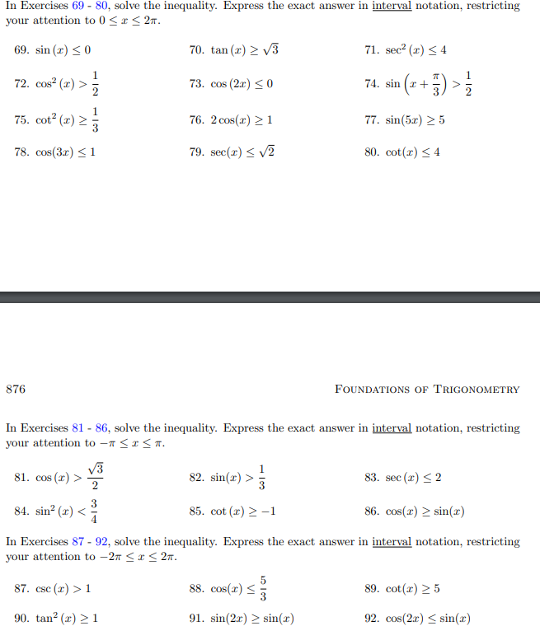

MFG 6.5:

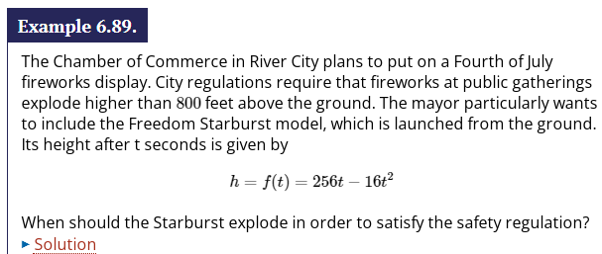

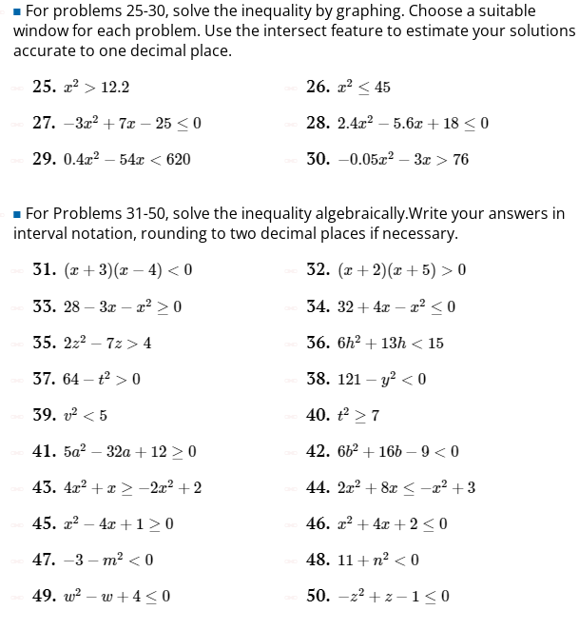

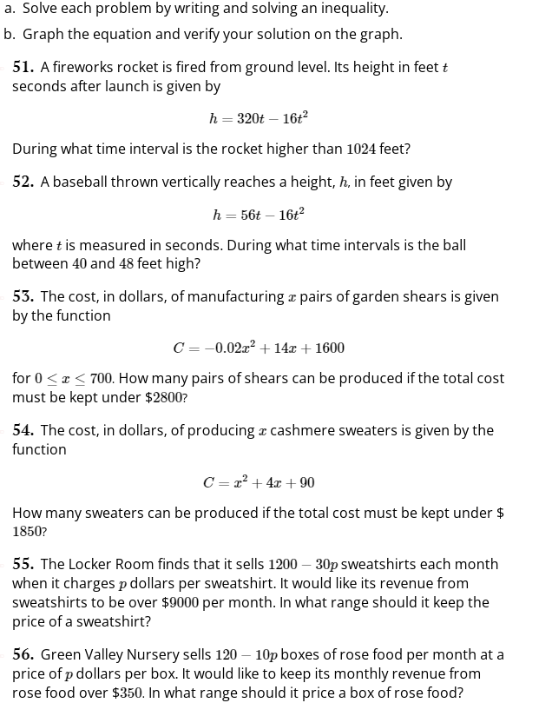

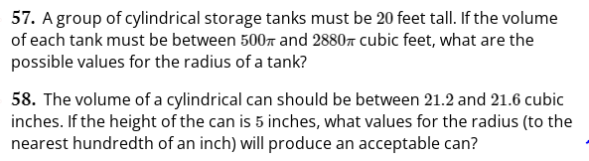

MFG Chap, 6 Review

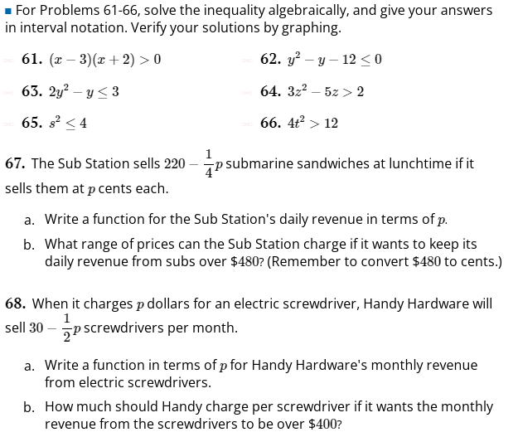

ORCCA: p. II-245:

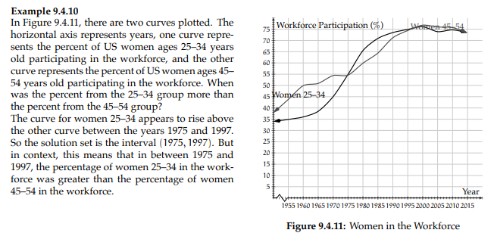

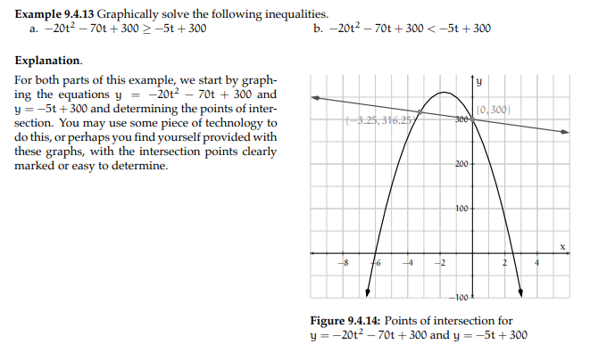

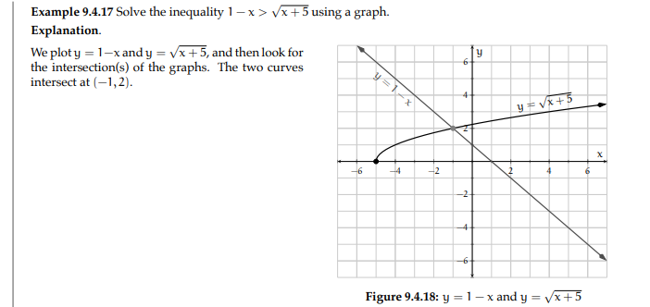

ORCCA p. III-271

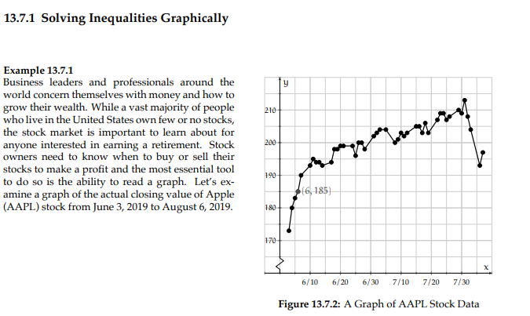

Active Reading 1.3:

**12-3: Average Rate of Change: Difference Quotients**

Some like average rate in many applications, with units expected. Also, give expression and ask what the expression means in application and/or give f(x) and interval.

Give “Find average rate on interval” and then ask the same with h notation and compare.

Flipped Math Unit 15

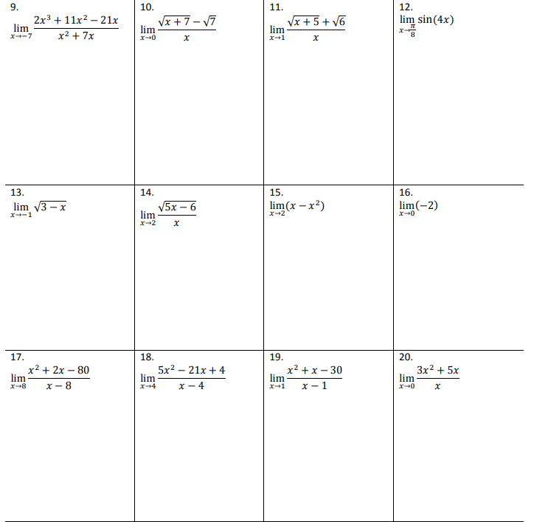

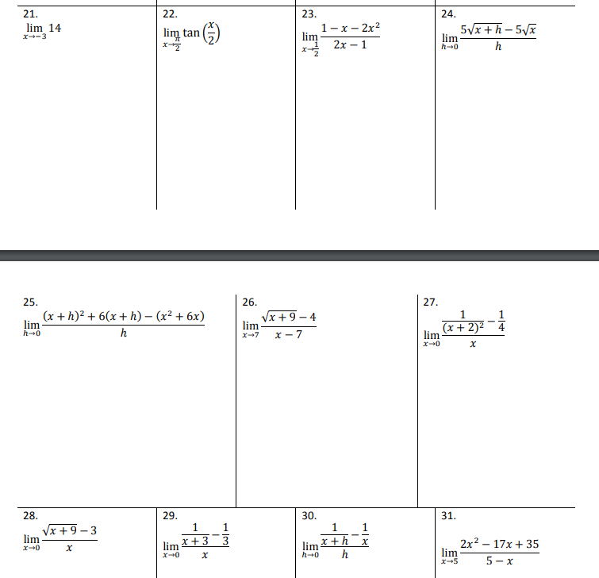

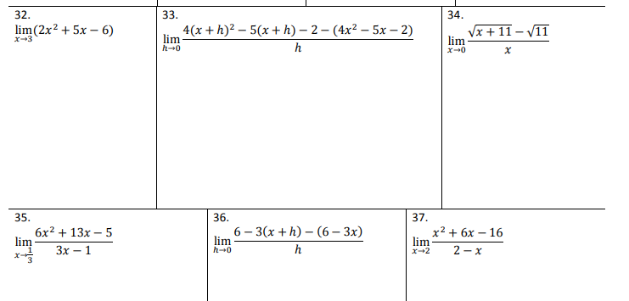

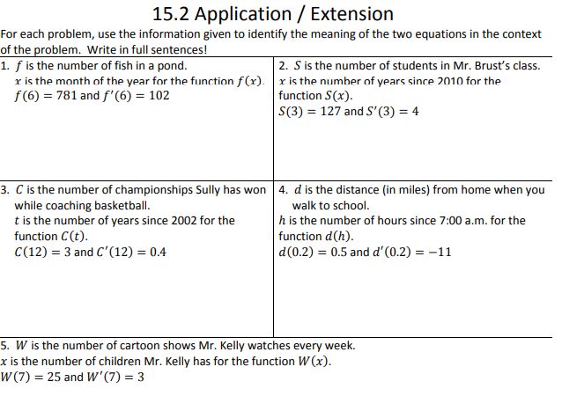

Active Reading 1.3

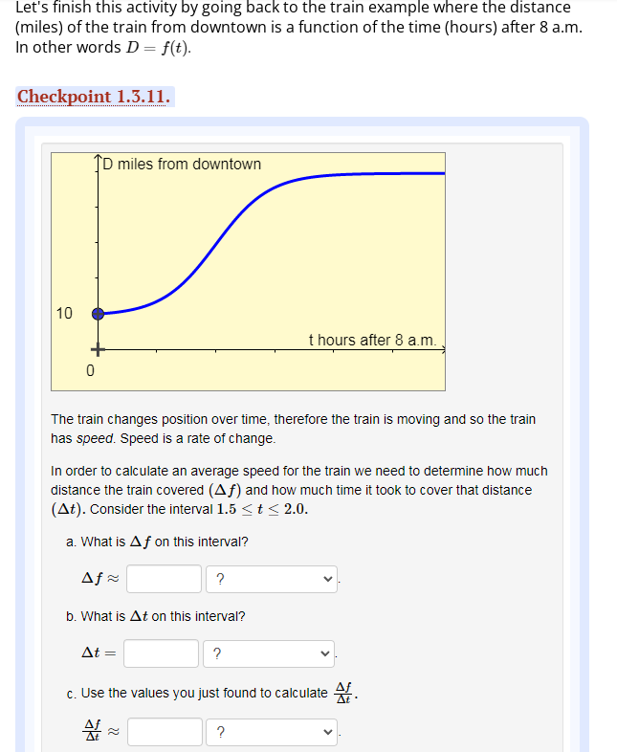

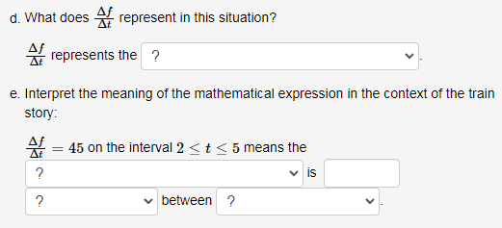

Calc-Medic 9.1:

Section 9.1—Average versus Instantaneous Rate of Change

|  |
| --- |
| Important Ideas: |

Check Your Understanding!

1. Calendar

   Description automatically generatedThe temperature of a pot of tea as it is cooling is given by the function , measured in ˚Celsius. Time, *t*, is measured in minutes.
   1. How fast is the tea cooling, on average, over the ten minute interval? Show work and include units.
   2. Estimate the rate at which the temperature of the tea is changing at . Explain your method.
2. Find the average rate of change of on the interval [-1, 4].
3. Which is greater: the instantaneous rate of change of at or at ? How do you know?
4. The graph of is shown to the right.
   1. Find the average rate of change of on the interval . Show work.

* 1. Order the following from 1=least to 4=greatest:

_____Average rate of change on

_____Instantaneous rate of change at

_____Average rate of change on

_____Instantaneous rate of change at